**CURRENCY SETTINGS**

1. First set up all your currency codes for each country in your general ledger file maintenance menu (GF5) as seen below.  All you need is the exchange rate and the account number filled in for your gain/loss for each country code. If you sell to multiple countries you will have to set a code for each country including your own.

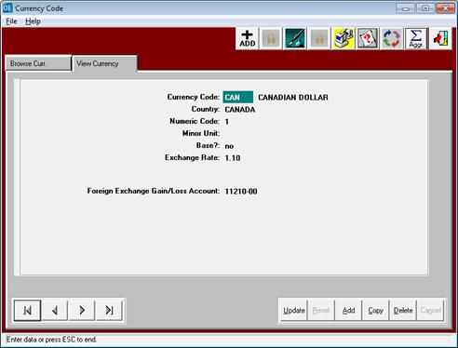

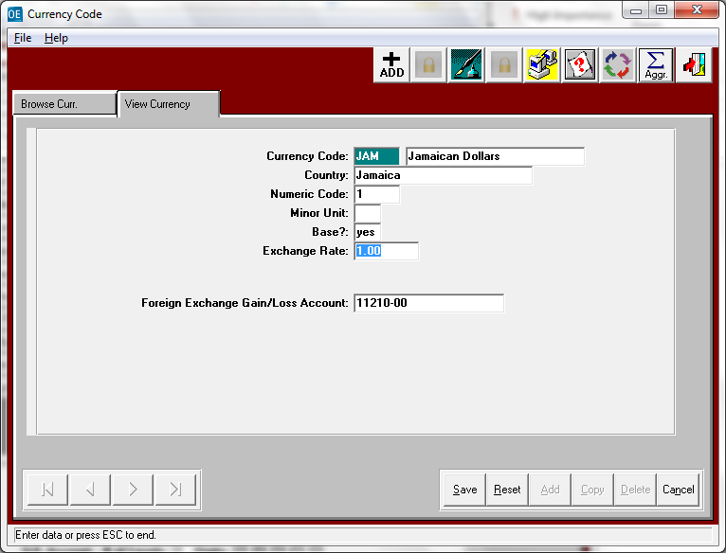

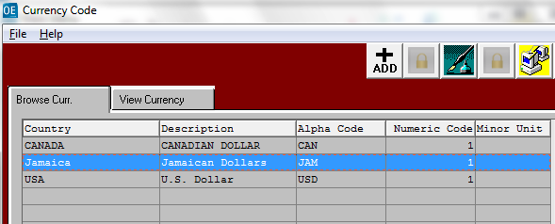

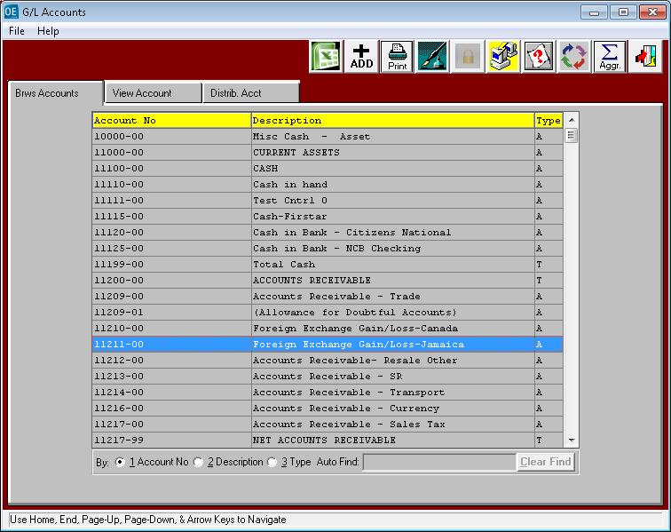

1. Set up your company file default currency code in (GF1) Company file.

Your company can be maintained in Canadian dollars, Jamaican dollars, or other.

The company file sets your default currency. This currency will be used for all reports.

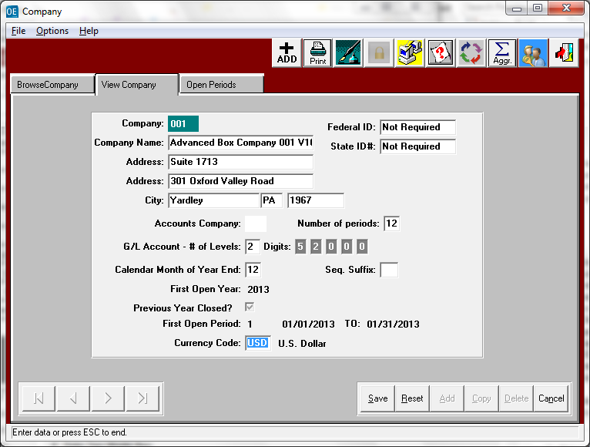

1. Set up each Customer and Vendor with their respective currency code.

When the customer or vendor currency does not match the Company Currency, our software uses the exchange rate to calculate the dollars.

Set up your customers with the correct currency code in their customer file (AF1)

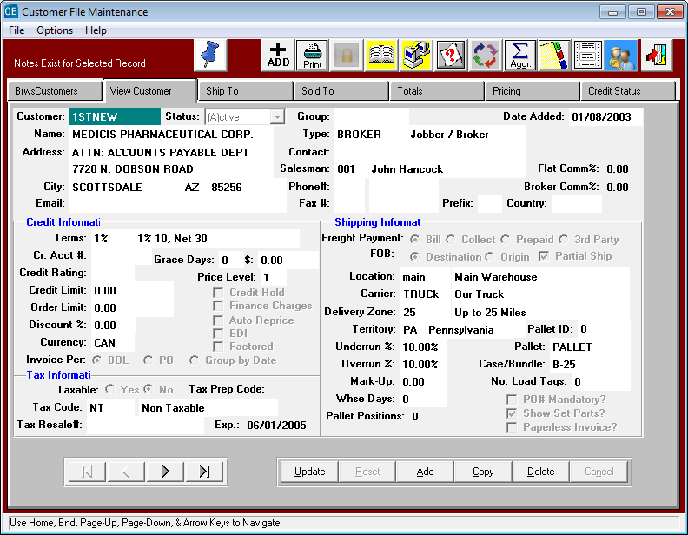

1. Set up your Vendors with the correct currency code in their vendor file (VF1) 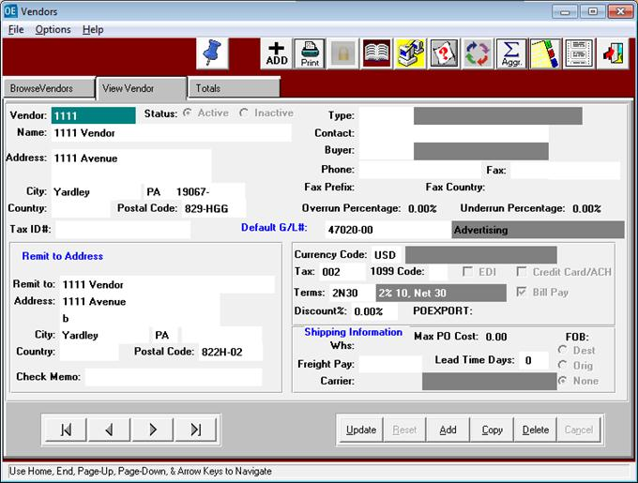

See below for when you post an AR invoice.  As you can see it makes the adjusting entry to the gain/loss account automatically. It will make this adjustment for Payable invoice, cash receipts and also AP checks.

